File permissions in Linux

Project description
I implemented various Linux commands I’ve learned in order to assist me in experimenting with permission changes and observation of permissions on files, hidden files, and directories. These commands included the ls -l, ls-la, and chmod commands.

Check file and directory details

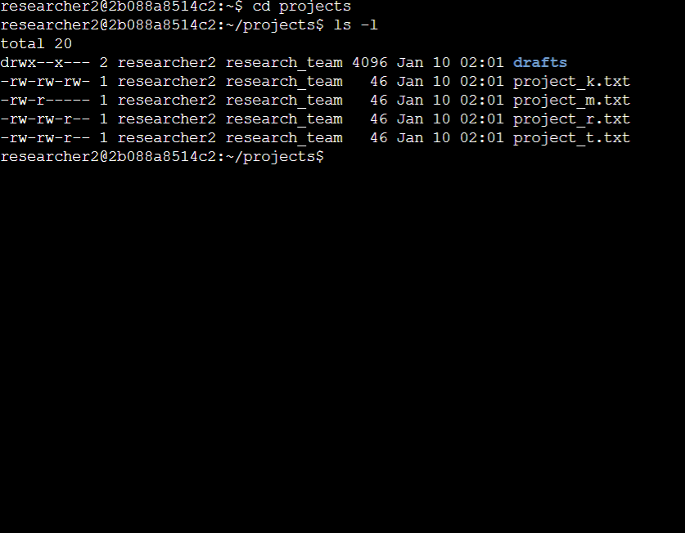
I used the cd projects command to change to the project directory. Afterwards used the ls -l command to display the current permissions for each file and directory.

Describe the permissions string
The image above displays each permission string for each file.For example, in the 10-character string -rw------ for project_m.txt the first - represents a file instead of a directory. The next three characters rw- represent read and write permissions as well as no execute permission for the user. The second three characters r-- represent a read permission but no write and execute permissions for the group. Lastly, the last three characters --- represent no permissions at all for other users.

Change file permissions
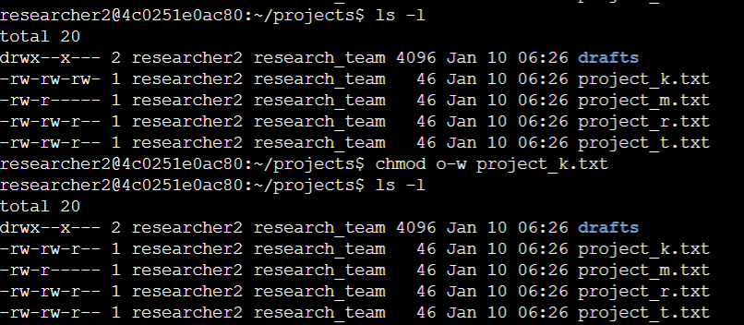
In the image above, I used the ls -l command to display all current file permissions. I needed to change the permissions so that none of the other users could write. According to the requirements, the file project_k.txt required modification. I used the chmod o-w project_k.txt command to take away write permissions for other users. As shown above I confirmed my changes by using the ls -l command again.

Change file permissions on a hidden file
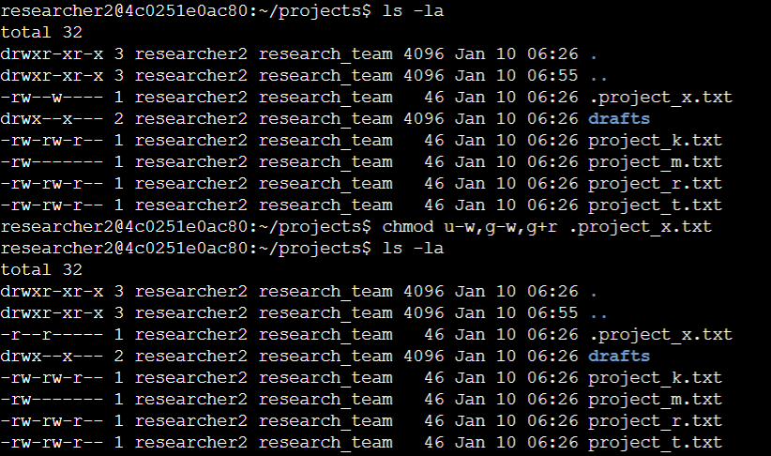
The image above shows the process of changing permissions on a hidden file that was shown by using the ls -la command. The file .project_x.txt is a hidden file that has been archived and should not be written to by anyone. (The user and group should still be able to read this file.). As shown above I used the command chmod u-w,g-w,g+r .project_x.txt to change the permissions and correctly adjust them as required.

Change directory permissions
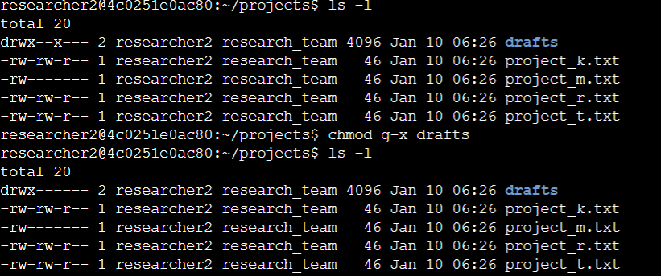
Only the researcher2 user should be allowed to access the drafts directory and its contents. (This means that only researcher2 should have execute privileges.) As shown in the image above, in order to accomplish these requirements, I first listed the files and subdirectories using the ls -l command to find the drafts directory. I then used the chmod g-x drafts command in order to take away execute permissions from the group to meet the requirements.

Summary
Throughout this project I was able to observe, experience, and apply permission modifications to files, hidden files, and directories. This showcases my basic understanding of how Linux commands work and how they can be applied in various scenarios.

